Angular 6+ Basics

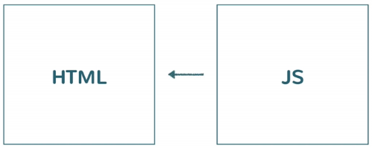
The traditional approach to front-end web development involves a static portion of HTML and then the dynamic portion JavaScript. The JS is then embedded in to your HTML, so when the HTML loads, the JS also gets loaded and the JS will manipulate the DOM with which you can achieve different functionalities like responding to user events and so on.
If you are following this approach, in any application these 2 things will be separated. For example: to show the current date: you will write a <div> in your html which will hold the date and with the JS you will get that dom element and update/manipulate that element to show the date on screen. You will do the same for every functionality.

Component Based Model
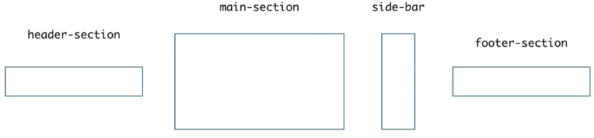
With Angular you don’t have this divide. You are thinking about components. As an Angular developer you wont think about the html and js separately. Firstly before building an app you need to think “which components will make up our app?”.
You can create/register new components with a custom name. In our angular app we can use those names/selectors to tell which component we are using.
Angular will pull the correct component and render it to the ui.

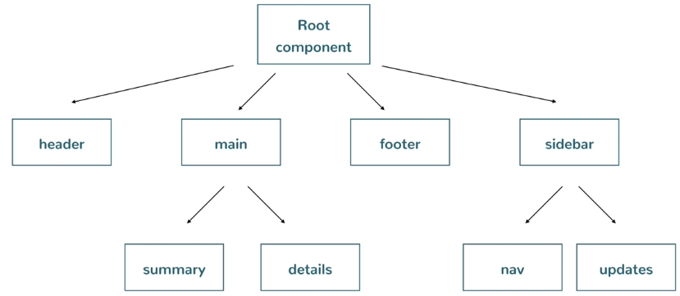
- These components can be nested.
You have a tree structure of components. A tree needs a starting point. That starting point is the root component. Every angular app will have a root component which is going to hold the main component which needs to be displayed. Those main components can have child components and so on.

Setting Up the Development Environment
- NodeJS, the runtime environment.
- Angular CLI, a way to startup a single angular project. Kickstart projects. A typical angular project will have multiple files that needs to be created so we usually don’t want to do it by hand.

Installing any node package has this format: npm install [packageName] -g
npm install @angular/cli -g -> without -g, it will install angular to the current directory. We don’t want that.

- When we download it globally, we can access that package from anywhere.

Creating a new project with Angular CLI

What angular CLI will do: create this project, create all the files that are associated with it and it also happens to be an npm project, so it is also doing an npm install, installing the dependencies.
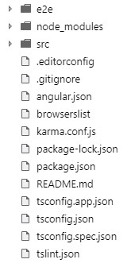
We are obviously using the angular library but this library needs to be in our project. Npm will download and install all the dependencies,all its doing is downloading related JS files and putting them in a folder. We will use those JS files in our code and HTML.
src/ - will contain our source coce
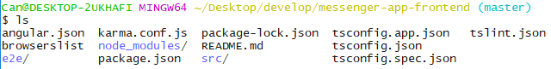
node_modules/ - here are all the downloaded dependencies.
package.json – list all the dependencies that we need
e2e – end to end testing

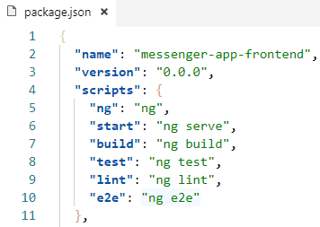
Running the project: ng serve
What this does, it creates a simple http server and hosts the angular project so you can access it locally
- Listens on localhost:4200

npm start -> executes ‘ng serve’
npm e2e -> does not run ‘ng e2e2’ ???

Project Structure
This project created a placeholder root component, helping us to create our own component and putting it inside the root. Since every project needs it, angular cli creates it for us.
The root component is rendering all the things we see when we access localhost:4200.
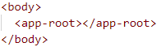
We are accessing index.html when calling localhost. We can see the root component is used in our application. This shows us all the things on screen.
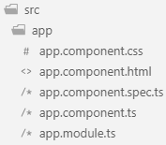
The root component is located in app/ directory. App is currenly the only component in this project.
- The files app.component.html, app.component.css and app.component.ts are the ones which provides the functionality and the look of the component. (view = html + css, logic=ts/js)
- app.component.spec.ts contains unit tests.
- app.modules.ts ??????????

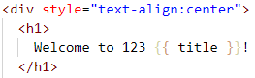
The dynamic portion of the .html file is coming from app.component.ts.

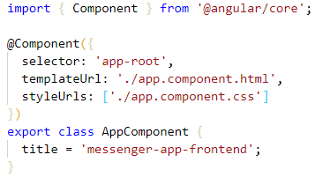

Create a new component
- Create a similar folder and files seen inside app/
- Use Angular CLI to generate a new component. ng generate component [name]
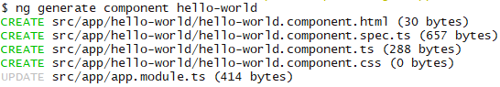
created 4 files,
updated 1 file
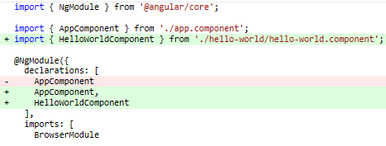
Updated app.modules.ts

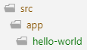
- Our new component hello-world was created under app/

How to use the newly created component?
Using the selector of the component. Each component has the html tag/selector which will render/instantiate that component.
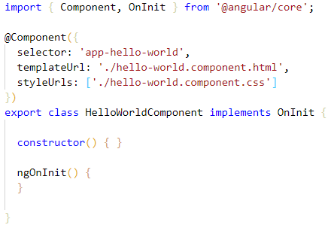
When we look inside hello-world.component.ts we can see which selector we need to use.
- This selector will instantiate this component. We can use this inside an html of a component and then it is going to call this as a child component.
- This selector can be used multiple times to create a new instance each time.
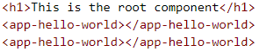
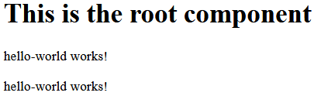
Adding functionality to a component
We will add a new ‘date’ component. ng generate component date.
To add functionality to components we need to understand some things first.
- Related files for a component are in the same directory, but what is the thing that puts all of those together?
Every Angular component is mainly a TypeScript class. Think of the HTML and CSS files as just extra “attachments” to the main TypeScript file. As a bare minimum for a component, you need to create a class. After that you need to register that class as an Angular component. This is done by providing some meta-data to the class.
- Create your class
- Register your class as an Angular component.

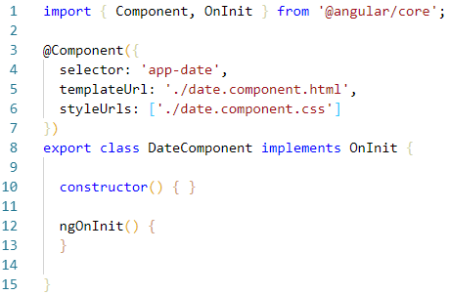
In this example we see:
Class definition: Line 8-15 is the class definition. This class implements an interface OnInit. The functionalities will go inside this class.
Registering your class: the annotation @Component(…) is actually responsible for registering this class as a component.
An annotation is a TypeScript way of adding meta-data to classes (similar to java, c#). Which doesn’t really effect the functionality of the code itself but its useful for frameworks or third-party libraries to examine your classes (kind of a tag).
This @Component(…) annotation takes an object as input. These properties then tell Angular how this component should behave.
- selector: registers this name and whenever this tag is used, a new instance of the corresponding class will be created.
- templateUrl: the url which contains all the markup / the template. The html to render.
- StyleUrls: An array of Strings (paths) to css files.
Binding data from component class
We need a way for the static part of our app to render the dynamic part. Calculate some value in the TS file, then display that value in the HTML.
- We will use a special syntax for this (double curly braces). Inside these braces you can reference member variables of your component class.
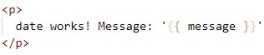
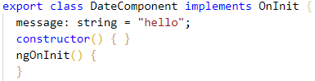

This concept of having a value in the class, then showing it in the view is what is referred as data binding. Its called data binding because its not a one time thing. The view automatically reflects the changes happening to the values of the class.
In this case it is a one-way binding because the component can change the value of its member variable and the view reads from it. Something sending the value, which is the TS class, and something reading it, the html file. A one-way flow of data. Done by using {{ }}.

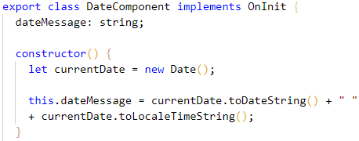
We want to update the date and time every second:
Right now the new Date object is created in the constructor. So, it currently only executes when the page is loaded which causes the component instance to be created.
We want the time to change every second.

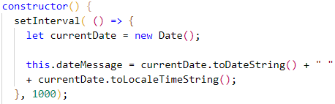
We will use a method setInterval(callbackFunction, time)
Because we are using the ‘fat-arrow’ function, the this keyword still refers to the component instance.

Template Interpolation
This double curly triggers Angular to do interpolation. String interpolation, expression interpolation. What this does it looks at the contents inside the double curly not as simple static text but as something that needs to be evaluated. Angular will switch to interpolation mode / evaluation mode when it sees something between double curlies and the result of this evaluation is what gets plugged in.
- We can put math expressions, adding two variables, method calls (for member functions of your class) inside the braces. You don’t have to write this. for member variable or method calls.
- Each time the underlying value changes, these expressions inside braces are evaluated automatically.

Looping with ngFor
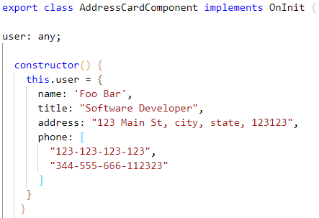
Creating a new component address-card.
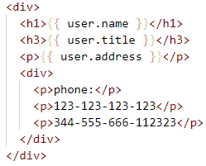
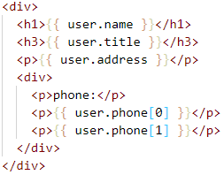

Tricky part is the phone, because it’s not one element, its an array. Lets say we want to get all the elements in the array and loop through them.

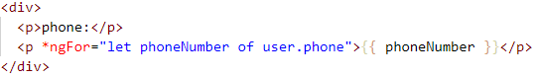
- This is what is called as a directive.(in angular 2+) A directive is an attribute you add to an element.

Using ngIf
What if there are no elements in the array? Actually all of them go away with no errors, but there is still that hard coded ‘phone’ paragraph at the top. We want to hide that phone string when there are no elements.
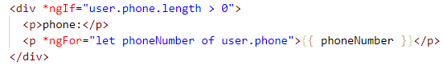
Now the div won’t show up when there are no elements

Since we are in JavaScript world we can do this:
When there will be a boolean evaluation and it gets a number 0, it will evaluate to false. Angular will remove the div from the DOM when it sees a false. It’s not hiding, it will be deleted when rendering.

Passing Inputs to Components
There are a couple way to do this. First we will look at the simple one, passing data in-line.
You can pass data at the point where the component is being used/called.
We can pass input by giving them to predefined names, like seen in the example. How do you ask angular to give us the value of the passed property to our component?
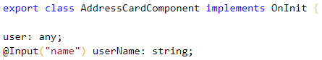
You can again use an annotation @Input(…) and give the name of the property.

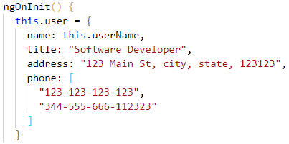
- Important: To be able to access and work with this.userName, the value given as input, we need to move our object to the ngOnInit() function in your class.

NgOnInit Lifecycle Hook
To understand why we need to put our object inside ngOnInit() we need to understand component lifecycle. When you use a selector angular creates an instance of that class. The constructor will run. Angular does some other things also.
After the creation of the object (execution of the constructor) it populates the values, for example @Input(…) Angular will inject the value to our annotated member.
- If we use our object in the constructor, the ‘ userName’ value won’t be set yet, will be empty in this example. Because Angular has not had a change to populate the field ‘userName’ with the given input value.
- This is why angular offers certain methods (life-cycle hooks) inside a class which are called when certain life-cycle events happens.
- When the component is fully initialized (after constructor), ngOnInit() will be called by Angular only if it is defined.

A component has a lifecycle managed by Angular.
Angular creates it, renders it, creates and renders its children, checks it when its data-bound properties change, and destroys it before removing it from the DOM.
Angular offers lifecycle hooks that provide visibility into these key life moments and the ability to act when they occur.
A directive has the same set of lifecycle hooks.
Directive and component instances have a lifecycle as Angular creates, updates, and destroys them. Developers can tap into key moments in that lifecycle by implementing one or more of the lifecycle hook interfaces in the Angular core library.
Each interface has a single hook method whose name is the interface name prefixed with ng. For example, the OnInit interface has a hook method named ngOnInit() that Angular calls shortly after creating the component:
- But even if you don’t write implements OnInit, it will still work fine. But if you write it and don’t implement , it then it will show a compile time error.
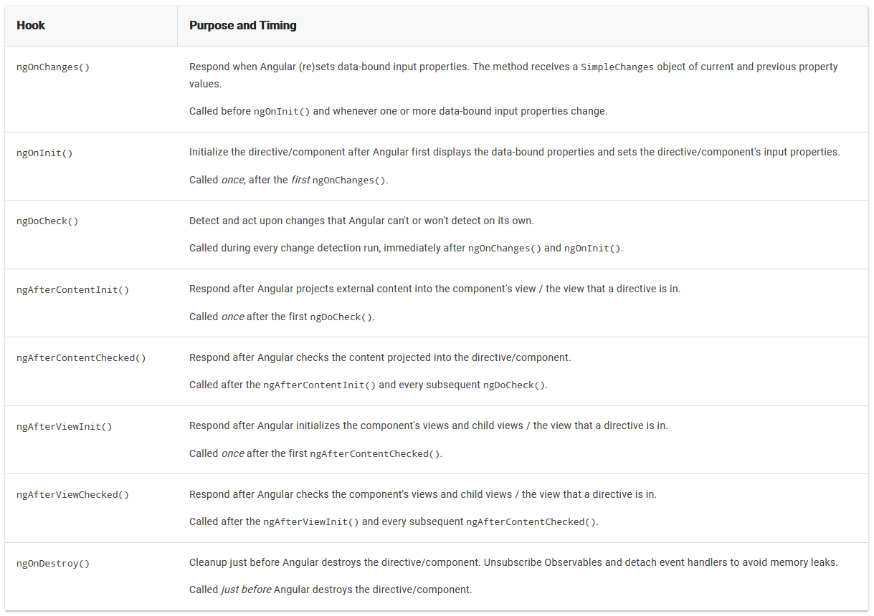

Passing member variables to components
Now we saw how we can pass data to components with properties. The problem is that we have a lot of other variables that we need to pass. But that is tedious, having too many parameters and having to pass data each time for each parameter.
It would be easy to just pass an object that contains all the values. We can create a User class and we can just pass a User instance to our component.
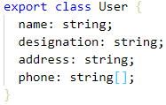
Since the AddressCardComponent is a child which is used by the AppComponent, the AppComponent has to pass the User instance.
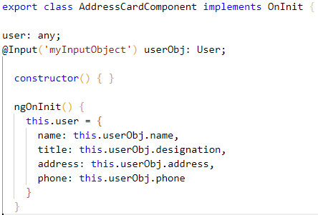
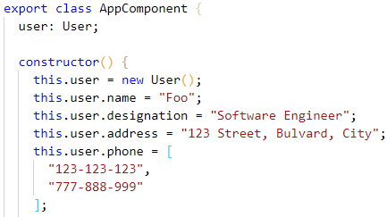

If we try to pass the user member variable to the component like this, it won’t work because Angular doesn’t evaluate it. It only sees it as a string “user”.

We need to tell Angular that we want to access a member variable and it is done by adding [ ]

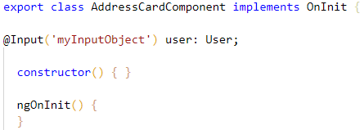
We can remove the assignments in our class now, since we already get a User object and will assign it to our member variable directly.

Styling Angular components
One thing we have to keep in mind when styling our components, it won’t work how we are expecting it to work.
- The styles in your .css file apply only to the markup in your component.

If you have two elements with class=”title” in app.component.html and also the address.component.html, the
.title { font-style: italic; }
inside address.component.css will only apply to the element for the address component.

This works because Angular adds additional selectors to our markup elements and also to our css files.In the developer tools we see an additional property appended to our css.
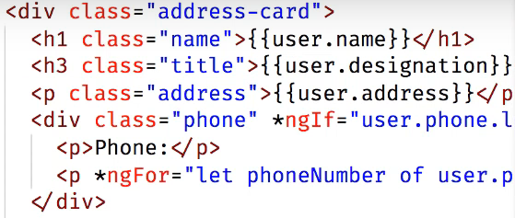
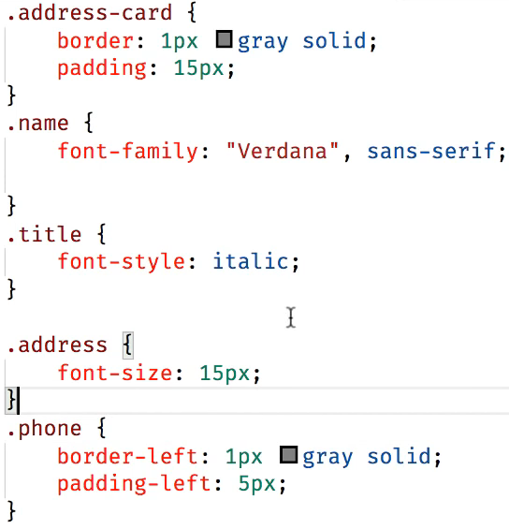
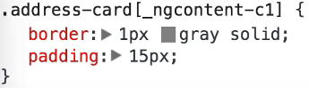
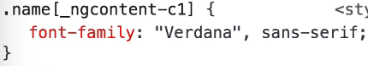
- The [property] selector is used in CSS to style elements that have that particular property. For example: <div property> </div>

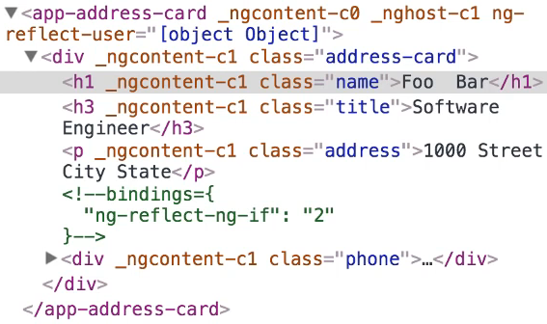

This is the way how Angular makes css styles apply only to components where it was defined.
This is a problem in big front-end projects because you will have a lot of selectors with similar names and that makes styling more complex and you don’t want to change a style of a different component without knowing it.
Usually what developers do is to make the class names really specific so that the styling won’t interfere with each other. This is why naming schemes like BEM (block element modifier) is used.
What if you want a global styling? You don’t want to put it to each component every time.
- In order to style components globally, you can use the ‘styles.css’ file in the src/ folder in your project.

Handling click events
Lets add a button which expands and collapse some information.
Normally you would have an onClick=”myMethod()” property on a html element which will trigger a global js function when the button is clicked. But here we want to call a method inside our AddressCard component. We can do this by wrapping the attribute name with ( attr )=”methodName()”.
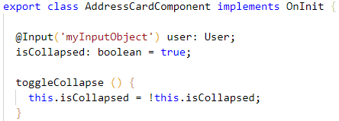
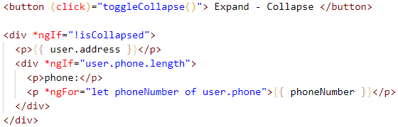

Make the button text dynamic and change it depending on the isCollaped value without using two buttons?

Two way data binding
It is not often used, not so much as one way data binding. This comes into play when you have forms, input fields, you want the component to take the data from the view. The component might use that data and all the other views that reference it will update automatically as we saw already with one-way data binding.

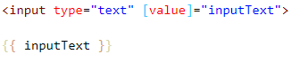
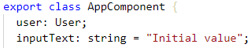
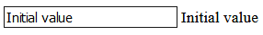

Right now when I change the value inside the input field, the text to the right is not changing. This means it has still one way data binding.
We can use a directive called ngModel to achieve two-way data binding. We also need to make another modification. This also requires an understanding of the modules concept in Angular. At this moment we will change the app.modules.ts class and add a new import FormsModule. It is not included with the initial CLI project so we had to import it since not everyone won’t need it.
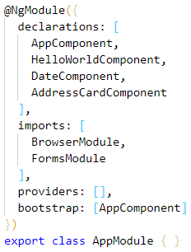
- Square brackets [ ] -> get the value from the component named ‘inputText’, it is not pushing back the changed value to the component
- Now we have two-way data binding. This syntax is referred usually as banana-in-a-box [( )].
- Paranthesis ( ) -> indicates a flow to the other direction. As we saw, a view even triggering a (click)=”toogleCollapse()” method.
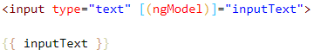
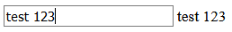

Modules
A module is container, namespace. You will create many modules in your project which will contain modules and many other things. Modules help organize your code. You can have feature-modules which contains all the things necessary for a particular feature. Then anybody who needs that feature will use that module.
Angular apps are modular and Angular has its own modularity system called NgModules. NgModules are containers for a cohesive block of code dedicated to an application domain, a workflow, or a closely related set of capabilities. They can contain components, service providers, and other code files whose scope is defined by the containing NgModule. They can import functionality that is exported from other NgModules, and export selected functionality for use by other NgModules.
Every Angular app has at least one NgModule class, the root module, which is conventionally named AppModule and resides in a file named app.module.ts. You launch your app by bootstrapping the root NgModule.
While a small application might have only one NgModule, most apps have many more feature modules (Feature modules are NgModules for the purpose of organizing code). The root NgModule for an app is so named because it can include child NgModules in a hierarchy of any depth.

An NgModule is defined by a class decorated with @NgModule(). The @NgModule() decorator is a function that takes a single metadata object, whose properties describe the module. The most important properties are as follows.
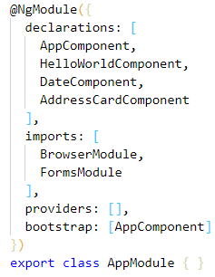
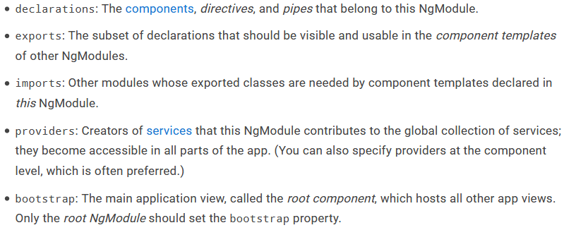

A root NgModule has no reason to export anything because other modules don't need to import the root NgModule.
Modules are a great way to organize an application and extend it with capabilities from external libraries.
Angular libraries are NgModules, such as FormsModule, HttpClientModule, and RouterModule. Many third-party libraries are available as NgModules such as Material Design, Ionic, and AngularFire2.
Modules can also add services to the application. Such services might be internally developed, like something you'd develop yourself or come from outside sources, such as the Angular router and HTTP client.
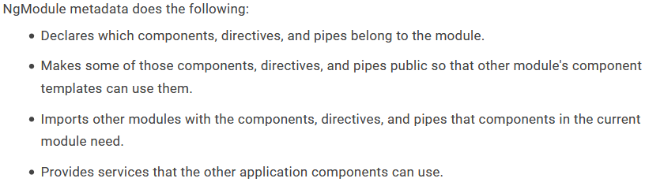
- Modules can be loaded eagerly when the application starts or lazy loaded asynchronously by the router.
NgModules and JavaScript modules
The NgModule system is different from and unrelated to the JavaScript (ES2015) module system for managing collections of JavaScript objects. These are complementary module systems that you can use together to write your apps.
In JavaScript each file is a module and all objects defined in the file belong to that module. The module declares some objects to be public by marking them with the export key word. Other JavaScript modules use import statements to access public objects from other modules.
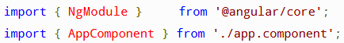
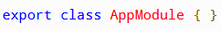

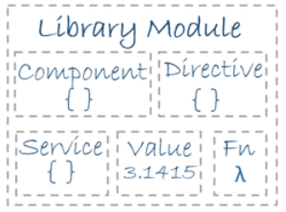
Angular Libraries
Angular loads as a collection of JavaScript modules. You can think of them as library modules. Each Angular library name begins with the @angular prefix. Install them with the node package manager npm and import parts of them with JavaScript import statements.
For example, import Angular's Component decorator (and some others) from the @angular/core library like this.
You also import NgModules from Angular libraries using JavaScript import statements. For example, the following code imports the BrowserModule NgModule from the platform-browser library.
In the example of the simple root module above, the application module needs material from within BrowserModule. To access that material, add it to the @NgModule metadata imports like this.
In this way you're using the Angular and JavaScript module systems together. Although it's easy to confuse the two systems, which share the common vocabulary of "imports" and "exports".
Creating and using modules
Don’t use camel-case naming, Angular will convert it all to lowercase with dashes between words.
will generate a new folder under app/ called my-new-module/.
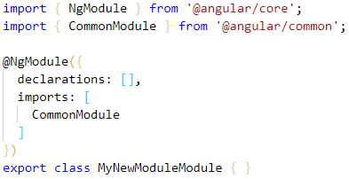
And appends ‘Module’ to the name you provided
- app.modules.ts did not change at all.
- CommonModule: ???

To create a new component inside this module we need to also pass the folder name to Angular CLI:
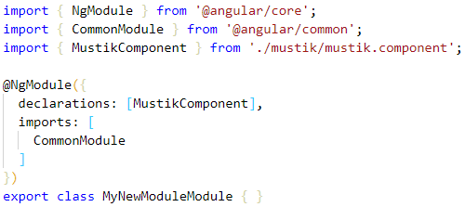

appends ‘Component’ to the name you provided

Use the new component in another module
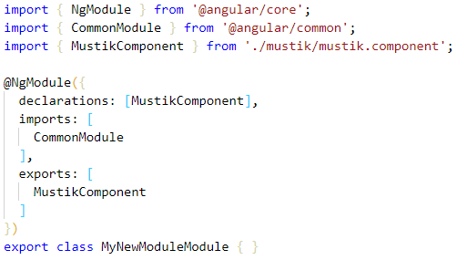
1. For other modules to use MustikComponent, we need to export it (make it public in a way). This is done in the module which contains the component.
If no export happens, our root module cannot see or access other modules’ elements (unless its a built in module(?)).

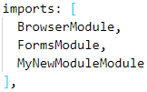
2. I want to use MustikModule in my root app component. Any time a module will use another modules component (or smth else), it has to state the name of the module in the ‘imports’ array of the using module (in this case appModule). Establishing a dependency with another module.
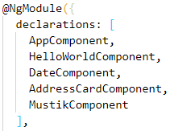
3. Add the used module to the ‘declarations’ array.
Services

HTTP

Component Lifecycle

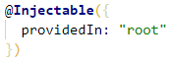
Different ways to make a service/component (?) singleton.
This service component will only be created again on page refresh (or new page).

But, normal components like Home, Login,… will be instance per call. A new instance will be created each time this component is used/called somewhere.

